

**Excel Assignment - 7**

1. **Using Insert Function, give examples of any function available in the different dropdowns present in the function library. For example AutoSum, Recently Used, Text, Date & Time, etc.**

**Answer:** 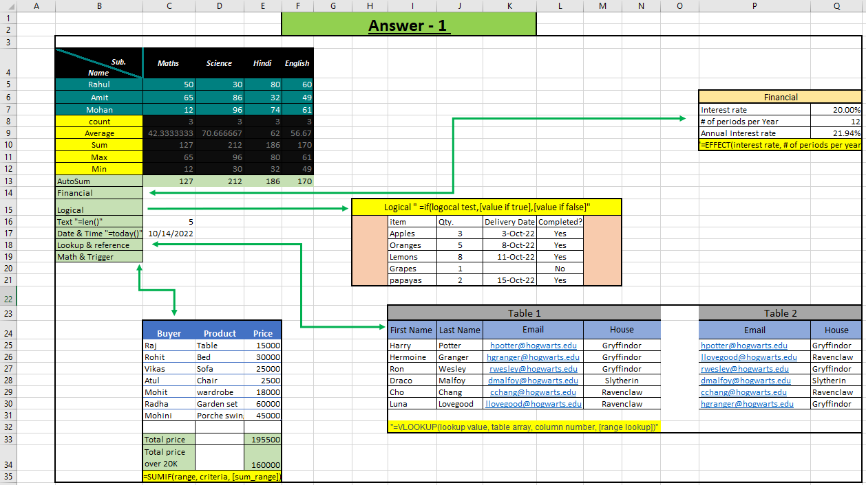

1. **What are the different ways you can select columns and rows?**

**Answer:** Columns can be directly selected by clicking alphabets present in top rows and by clicking “ctrl + space” and similar to this, rows can be selected by clicking on rows number and also by clicking “shift + space”.

1. **What is AutoFit and why do we use it?**

**Answer:** AutoFit means it automatically measures the width and height of the data and adjusts it accordingly and we used it to adjust height of rows and width of columns very easily by double clicking on the column and rows corner by hovering there an arrow appear and click on it. And there are other ways as well to do this.

1. **How can you insert new rows and columns into the existing table?**

**Answer:** By hovering on the rows number and column number, right click there and there is a list appear select insert and the requires column and rows added. Another way is available in ribbons in cells click on insert and there are options of insert rows and insert columns available.

1. **How do you hide and unhide columns in excel?**

**Answer:** For hiding column select column and right click there is a option to hide and unhide other way is in the ribbons in cells select format there is option available for hide and unhide and there is also shortcut present to hide by click on any cells and select column and there press “ctrl + 0” and to unhide click “ctrl + shift + )”.

1. **Create an appropriate table within the worksheet and use different functions available in the AutoSum command.**

**Answer:** 

